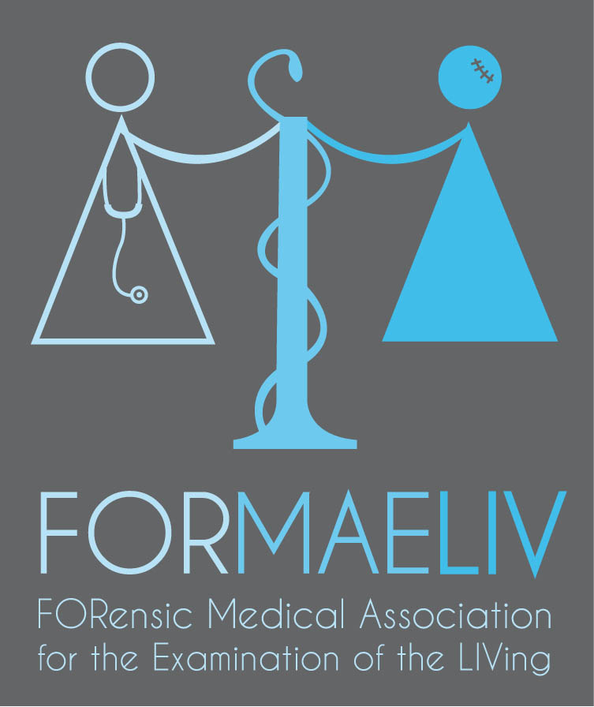

INTERNATIONAL WORKSHOP ON FORENSIC PHOTOGRAPHY
MAY 16th and 17th, 2018
MONTPELLIER (France).

CHU DE MONTPELLIER - HOPITAL LAPEYRONIE
ORGANISING COMMITEE
Prof. Eric BACCINO, MD, Dr. Emmanuel MARGUERITTE, MD,
Department of forensic medicine, University Hospital of Montpellier, France
THE TRAINERS
- Professionnal photographers
- Forensic clinical and Crime scene investigation specialists
OBJECTIVES
To acquire the basics of photography and apply them to forensics in order to obtain quality
photographs for functional use (for legal or educational purposes for instance)
To develop mechanical reflexes in order to be able to adapt to the variety of situations faced
by forensics (from a victim’s lesions to an outdoor crime scene, low lighting etc...)
Level Required : all levels
Who should attend : beginners, amateurs and advanced amateurs
Languages available for the workshop : English and French
Material required : camera, laptop / touch screen tablet and a USB stick.

PROGRAMME

DAY 1  - Basic knowledge in photography: luminosity, shutter speed, sensitivity, diaphragm control, range of lenses (prime and zoom), functionalities of the flash  - Handling and understanding the camera. Which settings and modes to choose? (shutter speed or aperture priorities, manual or automatic)  - Crime scene photography recommendations  - Photographing lesions  - Bring your own slides: projection and lecture on photographs brought by trainees | Day 2  - Practical photography workshop with practical cases  - How to categorise and archive photos, which software to choose?  - Practical photography workshop in lifelike situations  - Projection and lecture on photographs taken during the course.

The Workshop on Forensic Photography precedes the INTERNATIONAL WORKSHOP IN CLINICAL FORENSIC MEDICINE taking place on 18th and 19th May 2018

REGISTRATION FEES (Registration deadline : March 30th 2017) :
Workshop on Forensic Photography : General public : 200 €,
Workshop on Forensic Photography : Members of FORMAELIV, AMLTCM or SFML : 135 €,
Workshop on Forensic Photography : Students : 100 €

Workshop in Clinical Forensic Medicine AND Workshop on Forensic Photography : General public : 450 €,
Workshop in Clinical Forensic Medicine AND Workshop on Forensic Photography : Members of FORMAELIV, AMLTCM or SFML : 300 €,
Workshop in Clinical Forensic Medicine AND Workshop on Forensic Photography : Students : 225 €

Registration will be done from the following link : https://www.weezevent.com/formaeliv

ANY INFORMATIONS :

e-margueritte@chu-montpellier.fr or
formaeliv@gmail.com
33 (0)4 67 33 85 86

