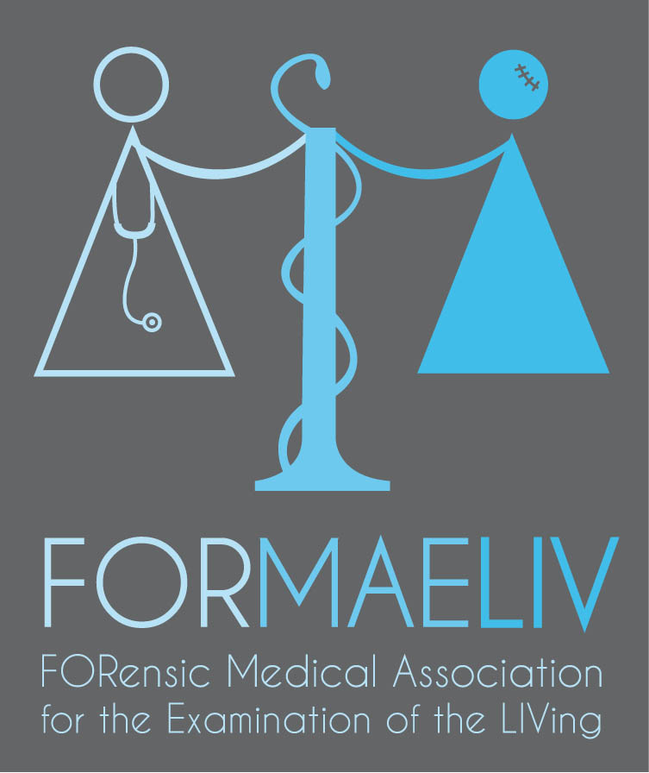

6th INTERNATIONAL
WORKSHOP IN CLINICAL FORENSIC MEDICINE
“ Domestic violence “
May 18thand 19th, 2018
MONTPELLIER (France)

Main speakers : Dr. M. NITTIS Blacktown Hospital, Australia, Dr M. STARK London UK,Prof. E. BACCINO, Montpellier France,Prof. C. CATTANEO, Milano, Italy Dr. G. HARING and Dr. T. ZUPANC, Slovenia Dr. F. CAUSSE-VERSAVEAU Montpellier, France.Dr. D. PASSERIEUX Montpellier, France. Dr. M. LACAMBRE, Montpellier, France.W. BODKIN, psychologist, Montpellier, France ; O. SAUTEL, Faculty of Law, Montpellier, France

AND
INTERNATIONAL WORKSHOP ON FORENSIC PHOTOGRAPHY
May 16th and 17th, 2018
MONTPELLIER (France)

ORGANISING COMMITTEE :

Prof. Eric BACCINO, MD, Dr. Emmanuel MARGUERITTE, MD,
Department of forensic medicine, University Hospital of Montpellier, France

THE TRAINERS
- Professional photographers
- Forensic clinical and Crime scene investigation specialists

LANGUAGE : ENGLISH for both workshops.

REGISTRATION FEES (Registration deadline : March 30th 2017) :
Workshop in Clinical Forensic Medicine AND Workshop on Forensic Photography : General public : 450 €,
Workshop in Clinical Forensic Medicine AND Workshop on Forensic Photography : Members of FORMAELIV, AMLTCM or SFML : 300 €,
Workshop in Clinical Forensic Medicine AND Workshop on Forensic Photography : Students : 225 €
Workshop in Clinical Forensic Medicine : General public : 300€
Workshop in Clinical Forensic Medicine : Members of FORMAELIV, AMLTCM or SFML : 200 €,
Workshop in Clinical Forensic Medicine : Students : 150 €
Workshop on Forensic Photography : General public : 200 €,
Workshop on Forensic Photography : Members of FORMAELIV, AMLTCM or SFML : 135 €,
Workshop on Forensic Photography : Students : 100 €

Registration will be done from the following link : https://www.weezevent.com/formaeliv

ORGANIZED BY : FORMAELIV (Forensic Medical Association for the Examination of the Living)

CONTACTS :
Detailed program, fees and registration: formaeliv@gmail.com
Any help : maguette.niang.mn@gmail.com

